**Contact Tracing**

Jewell and Roberts (2012)

Most papers look at how to predict who to contact trace / identify the people most likely to be infected

But this work is retrospective, and we want to incorporate contact tracing data into informing who, in the past, infected whom

**Ideas**

* Do we use incoming our outgoing?
  + Infector I 🡪 individuals S
  + individual S 🡪 Infector I
* Is this contact tracing dated?
* Is contact tracing binary?
  + Or does it count the number of contacts over time
* Contact tracing is probably going to be incomplete
  + Unobserved cases (sampling coverage) are not going to be traced
    - except in the potential cases of incoming and outgoing tracing converging on a given individual
  + Do we have to introduce another parameter which describes
* Given 100% contact tracing, if contact is not observed we should not assign transmission?
  + As in if π = 1, the number of generations kappa = 1
  + Similarly, if contact tracing ε = 1, and cij = FALSE, Tij = 0
  + ε = contact tracing
  + cij is contact tracing
  + Tij is proposed transmission
* How to deal with proposals >1 generation?
  + From contact tracing, a registered contact should provide support over proposing

$$Ω_{3}= ε^{c_{ij}}+ε(c_{ij}-1)$$

$c_{ij}$ is our contact tracing data between i and j

$ε$ is our parameter, namely the CTD coverage

* Features of this
  + If you have 100% coverage and cij = 0, transmission is impossible
  + If you have two network both with cij = 1 (if binary)
* Problems with this:
  + If coverage < 0.5, cij = 0 will lend **more** support to a proposed network than if cij = 1
  + i.e. a contact trace will **reduce** our confidence in transmission; makes no sense!
* Raw data
  + Incoming and Outgoing
    - Are these weighted equally?
  + Are these dated?
  + Number of ij contacts, or single time?
* Manipulating data for use
  + Simplest case: binary, single contact, not dated
    - We simply consider how contact **at some point** will increase likelihood of Tij
* What do we define as our parameter for fitting?
  + Do we define it as the coverage?
  + Do we define it as some kind of infectious parameter?
  + In the end, it should help in describing the likelihood of the CTD data (if binary, 0 or 1) given the proposed network
* Question
  + What acts as a dependent and independent variable?
    - If coverage < 0.5, will that mean we include networks with minimal cij = 1, meaning contact tracing reduces the likelihood of assigning transmission?
    - Or will cij = 1 mean we will choose coverage > 0.5 and lend support to networks with maximal cij = 1?
  + How to deal with unobserved generations?
    - We will not have contact tracing data for this: data is NA
    - But should we should still lend support to a case that has positive cij
* If we have dated, counted ij contacts
  + Jewell *et al.* used the following

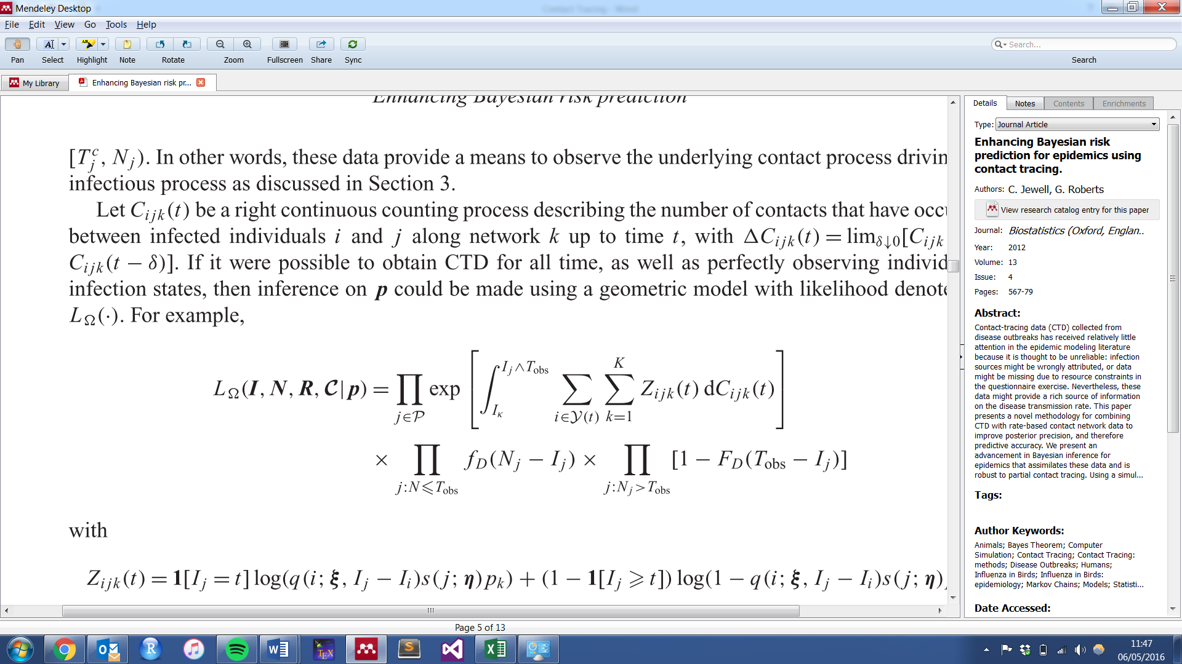

* + Ctd describes the number incoming and outgoing contacts from the time window Tcj (start of tracing) to time of Notification
  + Bottom line is essentially the f function from outbreaker (categorised into individuals that have been “detected” (N) before Tobvs and after)
  + p is defined as the probability of infection between a Cij contact
  + The summation terms are across all infectious (I and N) and across all networks
  + The Z term describes the infectious interaction, incorporating infectivity, susceptibility and p
  + We are integrating this Z-term over the temporal CTD data, describing the “number of contacts that have occurred between infected individuals i and j along network k up to time t”

What is the question?

How to describe the likelihood of observing the contact tracing data, given a transmission network?

Probability of observing contact tracing data, if our transmission network is true

We want our support lent to be weighted by the coverage; if we have high coverage, we want to provide support against a network if it doesn’t incorporate cij, and lend support for networks that are aligned with cij

**But**, cij = 1 should always be > cij = 0

What do we want to happen if coverage goes down, and cij = 1?

The likelihood of cij being 1 should go down, because it becomes less likely to observe

What we want:

We want the cij = 1 to always lend support over cij = 0

We want cij = 0 to provide support against that transmission, but less if coverage goes down

If coverage = 1 and cij = 0, p = 0

If coverage = 0.2

cij = 1

Check how you simulate contact data from simOutbreak

**expand.grid**

**sort out the double contacts**

**Now we use chi and eps**

**Chi is the probability of false positive / or relative probability of cij | infection vs cij | no infection**

**X is 1 for infectious contact and < 1 for non-infectious contact**

**It is good our test is at identifying a positive**

**Xsi is false positive (1-specifity)**

**Write the maths up**

**Write it in R**

**Make it a function**

**Generate graphs to illustrate**

**If we remove some of the nodes (ie number of generations > 1)**

**Have a matrix to represent CTD**

**Methods:**

**How do we model contacts**

**How we write it as a likelihood model**

**visNetwork for plotting networks**